Project 2
Dr. Nimm

Andrew Pena
CIS_5 – 44188
June 6th, 2017

Intro:
Dr. Nimm is a numbers game. I play it a lot, I usually play it to with people who are know it all's, and tend to wager something if I win. I let my family test it out, and some have the ego that the game is meant for. The game is designed like a magic trick, and if you can understand how it works then you can use it on others. However, once the trick is known, the game isn't as fun to play anymore by yourself. Use this game to trick friends, family, and peers. Win a few bucks, win a chance to humiliate a few people, win anything you can. Just try not to reveal the trick and have some fun.

Code Info:
In the Spreed sheet attached, I labeled everything I thought I used correctly. If there is something off, inaccurate, or incorrectly used please let me know. Version Three of the game is what I will base my pseudo code, flowchart, and even this write-up on. I made many versions, so that I could make the code run smoothly, that have as many concepts used inside but were to difficult for me to put all in one. The code is 348 Lines long, and I still plan to add to it.

Pseudo Code:
//Info About Creator

//System Libraries
//Input - Output Library
//Random Number Generator
//Library for Time
//String Library
//File I/O
//Format Library
//Name-space under which system libraries exist

//User Libraries

//Global Constants
//Like PI, e, Gravity, or conversions
//Conversion to Percentage

//Function Prototypes
//Bubble Sort
//Display Function
//Binary Search

//Execution begins here

//Declare variables

//Menu Information

//Show menu and loop

//Display Menu

//Input the choice

//Place solutions to problems in switch statement

//Variables Set for Program

//Display for Programs, States Rules, and allows user to have a winnable chance.

//Set the random number seed

//Declare all Variables Set for Program
//SIZE Array
//Number of Marbles for Game
//Number Selected for Guess Game
//To hold Search results
//Answer to play again
//Random Number
//Marbles Taken By player
//Symbols marbles for the materials for game (First Game Starts at 12)

//Loop for the game. If the user wants he/she can play again

//Random Number Generator for Guessing Game

//Process/Calculations Here
//Sort Array
//Display Array

//Search Array

//Enter Marble Chosen from Above Array

//Pause to let user have time to get ready to play game

//Game Start

//If/Else Statements to have computer choose what move to make

//Statement to take certain Random amount per turn

//Statement to take 1 Marble per turn

//Statement to take 2 Marbles per turn

//Statement to take 3

//loop for the program to keep going until only 4 marbles are left

//Users Turn to choose the amount of marbles to take

//If user does not take 1, 2, or 3 Marbles error will run and end game

//After User chooses it is computer turn

//If/Else Statements to have computer choose what move to make

//Statment to take RNG Number of Marbles

//Statement to take 1 Marble per turn

//Statement to take 2 Marbles per turn

//Statement to take 3 Marbles per turn

//At the 4th Marble the program will no longer loop

//If user does not take 1, 2, or 3 Marbles error will run and end game

//The game is at the end and the reaming marbles are left.

//If game is run without not cheating and not entering

//Option to play again

//If the user types Yes or yes the game will start again

//Declare file and game variables
//Output File
//Input File
//Result string
//Percentage of Winning
//Games Won
//Games Lost
//Total Games

//Initialize variables

//Check for error

//How Many Wins and Losses from reading in files

//Total Games Played
//Percentage of Winning

//Score Board

//Writing to File

//Close Files and Exit stage right!

//Exit stage right!

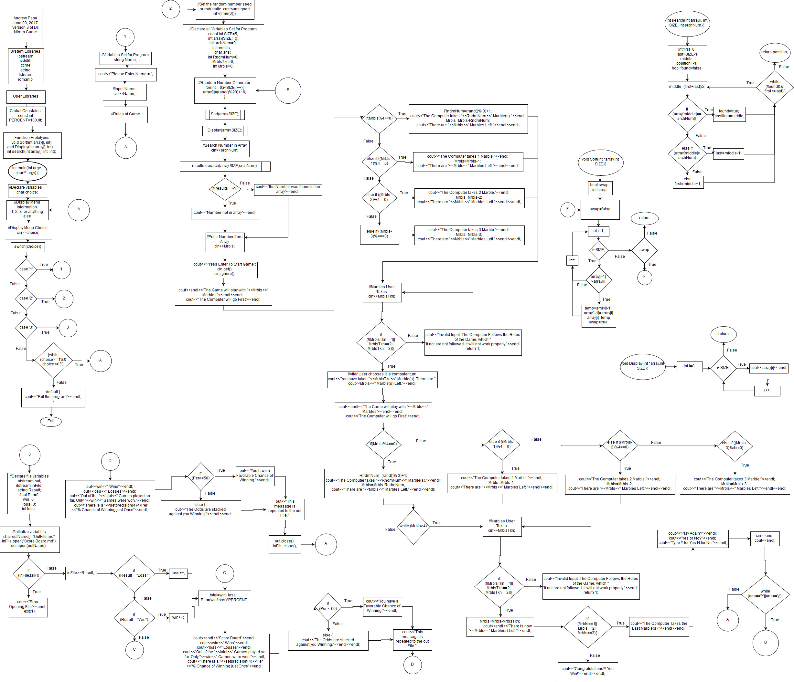
Flow Chart:

Program:
/*
* File: main.cpp
* Author: Andrew Pena
* Created on June 2, 2017, 1:04 AM
* Purpose: Version 3 of Dr. Nim Game
*/

//System Libraries
#include <iostream> //Input - Output Library
#include <cstdlib> //Random Number Generator
#include <ctime> //Library for Time
#include <string> //String Library
#include <fstream> //File I/O
#include <iomanip> //Format Library
using namespace std; //Name-space under which system libraries exist

//User Libraries

//Global Constants
//Like PI, e, Gravity, or conversions
const int PERCENT=100.0f; //Conversion to Percentage

//Function Prototypes
void Sort(int array[], int); //Bubble Sort
void Display(int array[], int); //Display Function
int search(int array[], int, int); //Binary Search

//Execution begins here
int main(int argc, char** argv) {
//Declare variables
char choice;

//Menu Information
cout<<"This is the Menu for the game Dr. Nim"<<endl;

//Show menu and loop
do{
//Display Menu
cout<<"--------------------------------------------------------------------------"<<endl;
cout<<endl<<"Type 1 for Instructions"<<endl;
cout<<"Type 2 To Play the Game"<<endl;
cout<<"Type 3 To Look at the Score Board"<<endl;
cout<<"Type anything else to exit"<<endl<<endl;

//Input the choice
cout<<"Would you Like to do?"<<endl;
cout<<"Number: ";
cin>>choice;
cout<<endl<<"--------------------------------------------------------------------------"<<endl;

//Place solutions to problems in switch statement
switch(choice){
case '1':{
//Variables Set for Program
string Name;

//Display for Programs, States Rules, and allows user to have a winnable chance.
cout<<"Please Enter Name = ";
cin>>Name;
cout<<endl<<"Welcome "<<Name<<". You get to play Dr. NIM!"<<endl;
cout<<"The Objective of this game is to try to take the last Marble."<<endl;
cout<<"The Rules are simple. The Computer will go first and it will choose One, Two, or Three Marbles."<<endl;
cout<<"After it decides how many to take, it will be your turn. You get to choose from One, Two, or Three Marbles."<<endl;
cout<<"The Game will continue until the last Marble is picked."<<endl<<endl;

cout<<"The Computer will generate a random number from 16 to 100 Marbles every game."<<endl;
cout<<"There is one trick to playing this game, and if you can understand it you will win every time."<<endl;
cout<<"This is a very simple game and once you learn how it works you may use this game to trick people and have some fun."<<endl;
cout<<"However, Many people have tried to win but have failed."<<endl;
cout<<"This game is in favor of the computer. So until the game is understood correctly, I would suggest to not give up until you have won at least once."<<endl;
cout<<"The game will be played with no mercy but once the trick is discovered you should win a vast majority of the time."<<endl;
cout<<"How will you play?"<<endl;
cout<<"Will You Win?"<<endl;
cout<<"Can you Discover the Trick?"<<endl;
cout<<"Good Luck! Also, if you do not win the first time you may play again."<<endl<<endl;

break;
}
case '2':{
//Set the random number seed
srand(static_cast<unsigned int>(time(0)));

//Declare all Variables Set for Program
const int SIZE=5;
int array[SIZE]={}; //Number of Marbles for Game
int srchNum=0; //Number Selected for Guess Game
int results; //To hold Search results
char ans; //Answer to play again
int RndmNum=0, //Random Number
MrblsTkn=0; //Marbles Taken By player
int Mrbls=0; //Symbols marbles for the materials for game (First Game Starts at 12)

//Loop for the game. If the user wants he/she can play again
do {

//Random Number Generator for Guessing Game
for(int i=0;i<SIZE;i++){
array[i]=(rand()%20)+16;
}

//Process/Calculations Here
Sort(array,SIZE);
Display(array,SIZE);

cout<<"Please enter a number to search if it is in array. The number will be used in the game as the starting Marble size."<<endl;
cin>>srchNum;

results=search(array,SIZE,srchNum);
if(results==-1)
cout<<"Number not in array"<<endl;
else
cout<<"the Number was found in the array"<<endl;

//Enter Marble Chosen from Above Array
cout<<"Please enter the number, from the above array you chose."<<endl;
cin>>Mrbls;

//Pause to let user have time to get ready to play game
cout<<"Press Enter To Start Game";
cin.get();
cin.ignore();

//Game Start
cout<<endl<<"The Game will play with "<<Mrbls<<" Marbles"<<endl<<endl;
cout<<"The Computer will go First"<<endl;

//If/Else Statements to have computer choose what move to make
if (Mrbls%4==0){ //Statement to take certain Random amount per turn
RndmNum=(rand()% 3)+1;
cout<<"The Computer takes "<<RndmNum<<" Marble(s)."<<endl;
Mrbls=Mrbls-RndmNum;
cout<<"There are "<<Mrbls<<" Marbles Left."<<endl<<endl;
}
else if ((Mrbls-1)%4==0){ //Statement to take 1 Marble per turn
cout<<"The Computer takes 1 Marble."<<endl;
Mrbls=Mrbls-1;
cout<<"There are "<<Mrbls<<" Marbles Left."<<endl<<endl;
}
else if ((Mrbls-2)%4==0){ //Statement to take 2 Marbles per turn
cout<<"The Computer takes 2 Marble."<<endl;
Mrbls=Mrbls-2;
cout<<"There are "<<Mrbls<<" Marbles Left."<<endl<<endl;
}
else if ((Mrbls-3)%4==0){ //Statement to take 3 Marbles per turn
cout<<"The Computer takes 3 Marble."<<endl;
Mrbls=Mrbls-3;
cout<<"There are "<<Mrbls<<" Marbles Left."<<endl<<endl;
}

//loop for the program to keep going until only 4 marbles are left
while (Mrbls>4){

//Users Turn to choose the amount of marbles to take
cout<<"Enter The Amount of Marbles you wish to take for Your Turn = ";
cin>>MrblsTkn;

//If user does not take 1, 2, or 3 Marbles error will run and end game
if(!(MrblsTkn==1||MrblsTkn==2||MrblsTkn==3)){
cout<<"Invalid Input. The Computer Follows the Rules of the Game, which "
"if not are not followed, it will not work properly."<<endl;
return 1;
}

//After User chooses it is computer turn
Mrbls=Mrbls-MrblsTkn;
cout<<"You have taken "<<MrblsTkn<<" Marble(s). There are ";
cout<<Mrbls<<" Marble(s) Left."<<endl;

if (Mrbls%4==0){
RndmNum=(rand()% 3)+1;
cout<<"The Computer takes "<<RndmNum<<" Marble(s)."<<endl;
Mrbls=Mrbls-RndmNum;
cout<<"There are "<<Mrbls<<" Marbles Left."<<endl<<endl;
}
else if ((Mrbls-1)%4==0){ //Statement to take 1 Marble per turn
cout<<"The Computer takes 1 Marble."<<endl;
Mrbls=Mrbls-1;
cout<<"There are "<<Mrbls<<" Marbles Left."<<endl<<endl;
}
else if ((Mrbls-2)%4==0){ //Statement to take 2 Marbles per turn
cout<<"The Computer takes 2 Marble."<<endl;
Mrbls=Mrbls-2;
cout<<"There are "<<Mrbls<<" Marbles Left."<<endl<<endl;
}
else if ((Mrbls-3)%4==0){ //Statement to take 3 Marbles per turn
cout<<"The Computer takes 3 Marble."<<endl;
Mrbls=Mrbls-3;
cout<<"There are "<<Mrbls<<" Marbles Left."<<endl<<endl;
}
}

//At the 4th Marble the program will no longer loop and
cout<<"Enter The Amount of Marbles you wish to take for the Next Turn = ";
cin>>MrblsTkn;

//If user does not take 1, 2, or 3 Marbles error will run and end game
if(!(MrblsTkn==1||MrblsTkn==2||MrblsTkn==3)){
cout<<"Invalid Input. The Computer Follows the Rules of the Game, which "
"if not are not followed, it can not work properly."<<endl;
return 1; //Use of DeMorgans law to make clear
}

//The game is at the end and the reaming marbles are left.
Mrbls=Mrbls-MrblsTkn;
cout<<endl<<"There is now "<<Mrbls<<" Marble(s) Left."<<endl;

//If game is run without not cheating and not entering fair the game will win
if (Mrbls==1||Mrbls==2||Mrbls==3){
cout<<"The Computer Takes the Last Marble(s)."<<endl<<endl;
}
else{
cout<<"Congratulations!!! You Win!"<<endl<<endl;
}

//Option to play again
cout<<"Play Again?"<<endl;
cout<<"Yes or No?"<<endl;
cout<<"Type Y for Yes N for No."<<endl;
cin>>ans;
cout<<endl;
}

//If the user types Yes or yes the game will start again asking if you would like a fair match
while (ans=='Y'||ans=='y');

break;
}
case '3':{
//Declare file and game variables
ofstream out; //Output File
ifstream inFile;
string Result;
float Per=0, //Percentage of Winning
win=0, //Games Won
loss=0; //Games Lost
int total; //Total Games

//Initialize variables
char outName[]="OutFile.md"; //Character Array Name
inFile.open("Score Board.md");
out.open(outName);

//Check for error
if(inFile.fail()){
cout<<"Error Opening File"<<endl;
exit(1);
}

//How Many Wins and Losses from reading in files
while(inFile){
inFile>>Result;
if (Result=="Loss"){
loss++;
}
if (Result=="Win"){
win++;
}
}

total=win+loss; //Total Games Played
Per=(win/loss)*PERCENT; //Percentage of Winning

//Score Board
cout<<endl<<"Score Board"<<endl;
cout<<win<<" Wins"<<endl;
cout<<loss<<" Losses"<<endl;
cout<<"Out of the "<<total<<" Games played so far. Only "<<win<<" Games were won."<<endl;
cout<<"There is a "<<setprecision(4)<<Per<<"% Chance of Winning just Once"<<endl;
if(Per>=50){
cout<<"You have a Favorable Chance of Winning."<<endl;
}
else {
cout<<"The Odds are stacked against you Winning."<<endl<<endl;
}
cout<<"This message is repeated to the out File."

//Writing to File
out<<win<<" Wins"<<endl;
out<<loss<<" Losses"<<endl;
out<<"Out of the "<<total<<" Games played so far. Only "<<win<<" Games were won."<<endl;
out<<"There is a "<<setprecision(4)<<Per<<"% Chance of Winning just Once"<<endl;
if(Per>=50){
out<<"You have a Favorable Chance of Winning."<<endl;
}
else {
out<<"The Odds are stacked against you Winning."<<endl;
}

//Close Files and Exit stage right!
out.close();
inFile.close();

break;
}
default:{
cout<<"Exit the program"<<endl;
}
}
}while(choice>='1'&&choice<='3');

//Exit stage right!
return 0;
}

void Sort(int *array,int SIZE){
bool swap;
int temp;
do{
swap=false;
for (int i=1;i<(SIZE);i++){
if(array[i-1]>array[i]){
temp=array[i-1];
array[i-1]=array[i];
array[i]=temp;
swap=true;
}
}
}
while(swap);
}

int search(int array[], int SIZE, int srchNum){
int first=0,
last=SIZE-1,
middle,
position=-1;
bool found=false;
while(!found&&first<=last){
middle=(first+last)/2;
if(array[middle]==srchNum){
found=true;
position=middle;
}
else if(array[middle]>srchNum)
last=middle-1;
else
first=middle+1;
}
return position;
}

void Display(int *array,int SIZE){
for(int i=0;i<SIZE;i++){
cout<<array[i]<<endl;
}
}

